Due Date: 15 Dec, 2020

Classwork name: Component and Dynamic Data

Teacher name: James Heggs

Team: Readers (Samantha Burke, Winndie Fan, Rebeca Sciamanna, Anita Caron)

Book container

The book container compiles of three components: book, stock and request. All three components contain dynamic datasource from JSON files on github repo <https://github.com/yrtt-readers/the-bookclub.git>, or Open library API.

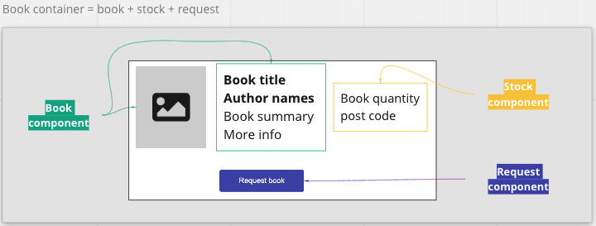

Book component

Book summary is a flexible textbox, user click [More] full description (max words), click [Less] short description (x number of words).

Thumbnail is an image tag, displaying pre pre-rendered images when the thumbnail is not available.

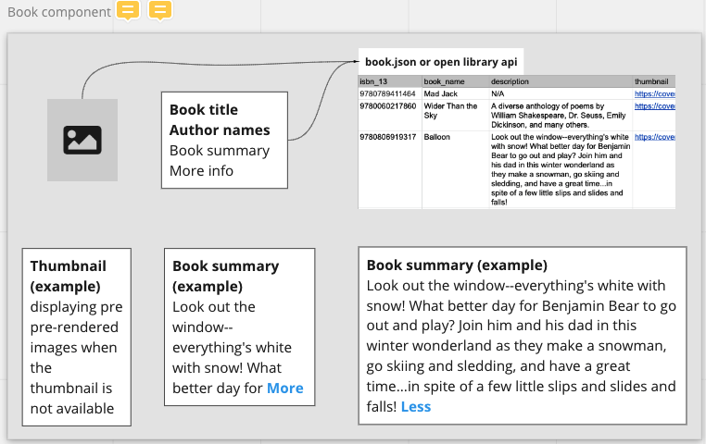

Stock component

Number of copies in stock will be group by postcode + sum(qty)

books out of stock will display N/A

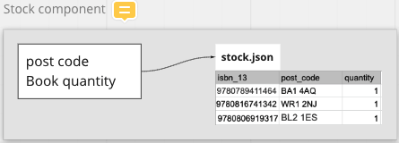

Request component

User click on [Request] button to open request component, h/she can enter number of copies request, postcode will be filled from user's information in database.

[Request] component will also display awaiting requests with postcode+qty.

